Ideation Phase
Brainstorm & Idea Prioritization Template

Date | 3 October 2026
Team ID | SWTID-2026-3708
Project Name | Streamlining IT Procurement: Automating Standard Laptop Orders with Flow Designer
Maximum Marks | 4 Marks

Brainstorm & Idea Prioritization Template:
Brainstorming provides a free and open environment that encourages everyone within a team to participate in the creative thinking process that leads to problem solving. Prioritizing volume over value, out-of-the-box ideas are welcome and built upon, and all participants are encouraged to collaborate, helping each other develop a rich amount of creative solutions.
Use this template in your own brainstorming sessions so your team can unleash their imagination and start shaping concepts even if you're not sitting in the same room.
Reference: https://www.mural.co/templates/brainstorm-and-idea-prioritization
Step-1: Team Gathering, Collaboration and Select the Problem Statement
Team gathering and collaboration
Name | Role in team
A Yashmin | Team Leader
Rishwana Parveen S | Team Member
Deepika Sri M | Team Member
Pooja S | Team Member

Selected problem statement: The current IT procurement process lacks efficiency and automation, causing delays and manual overhead in handling standard laptop orders. The configuration step is prone to oversight or delay, frustrating users and wasting IT resources.

Step-2: Brainstorm, Idea Listing and Grouping
Ideas listed and grouped by theme
Group | Ideas brainstormed
A. Ordering and intake | I1: Single 'Standard Laptop' catalog item with fixed specifications (Lenovo Carbon x1)  Optional software checkboxes and a free-text field for extra software
B. Approval and governance | I3: Manager approval step before fulfilment starts  Auto-approve orders below a cost threshold
C. Task automation | I1: Auto-create a Catalog Task when the laptop is ordered  I2: Assign the task to the 'Hardware' group automatically  Pre-fill short description 'Laptop needs to Configured'
D. Notification and tracking | I4: Email alerts to requester and Hardware team  I6: Dashboard of open configuration tasks
E. Future enhancements | I5: Automatic stock / inventory check  I7: Auto-generate vendor purchase order  I8: Chatbot-based request intake

Step-3: Idea Prioritization
Idea prioritization (impact vs effort)
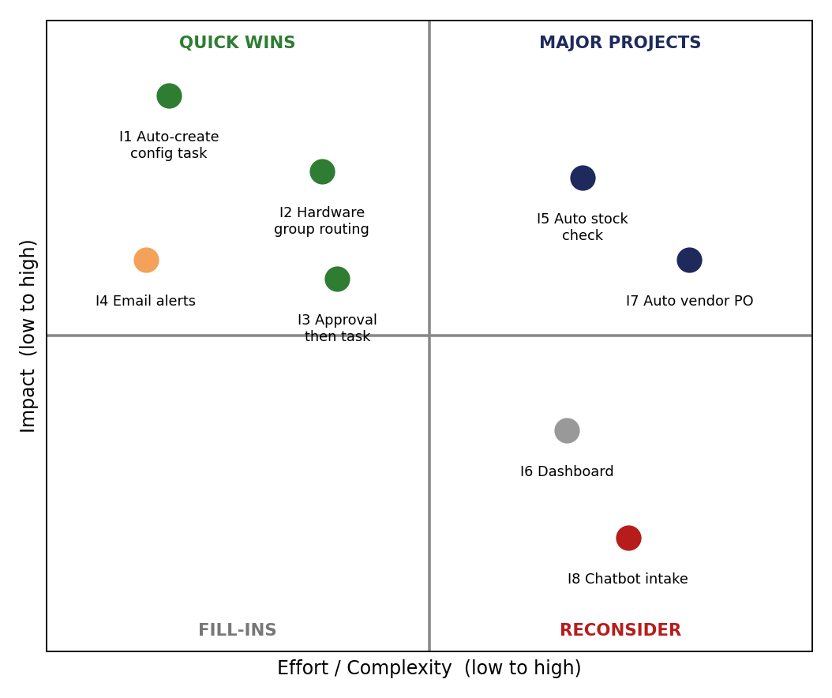
Idea | Impact | Effort | Decision
I1 Auto-create configuration task | High | Low | Implement (Milestone 1)
I2 Route task to Hardware group | High | Low | Implement (Milestone 1)
I3 Approval before fulfilment | Medium-High | Low-Medium | Implement (Milestone 3)
I4 Email alerts | Medium | Low | Future scope
I5 Automatic stock check | High | High | Future scope
I6 Dashboard | Low-Medium | Medium | Future scope
I7 Auto vendor purchase order | Medium-High | High | Future scope
I8 Chatbot intake | Low | High | Not prioritized

